Nama : Muh.Tsaqif Taufiqurrahman

Kelas : 5TKKO-E

Tabel Laporan Program

|  |  |  |  |  |
| --- | --- | --- | --- | --- |
| No. | Spesifikasi | Berhasil(√) | Kurang Berhasil(√) | Keterangan |
| 1. | Vigenere Cipher | √ |  | Bekerja dengan baik |
| 2. | Extended Vigenere Cipher | √ |  | Bekerja dengan baik |
| 3. | Playfair Cipher | √ |  | Bekerja dengan baik |
| 4. | Enigma Cipher | √ |  | Bekerja dengan baik |
| 5. | One-Time pad | √ |  | Bekerja dengan baik |

Source Program

import tkinter as tk

from tkinter import messagebox

def vigenere_cipher_standard(text, key, mode):

    alphabet_upper = 'ABCDEFGHIJKLMNOPQRSTUVWXYZ'

    alphabet_lower = 'abcdefghijklmnopqrstuvwxyz'

    result = ''

    key = key.upper()

    key_len = len(key)

    j = 0

    for i, char in enumerate(text):

        if char.isupper():

            shift = alphabet_upper.index(key[j % key_len])

            idx = alphabet_upper.index(char)

            if mode == 'encrypt':

                new_idx = (idx + shift) % 26

            else:

                new_idx = (idx - shift) % 26

            result += alphabet_upper[new_idx]

            j += 1

        elif char.islower():

            shift = alphabet_upper.index(key[j % key_len])

            idx = alphabet_lower.index(char)

            if mode == 'encrypt':

                new_idx = (idx + shift) % 26

            else:

                new_idx = (idx - shift) % 26

            result += alphabet_lower[new_idx]

            j += 1

        else:

            result += char

    return result

def vigenere_cipher_extended(text, key, mode):

    result = ''

    key_len = len(key)

    for i, char in enumerate(text):

        shift = ord(key[i % key_len])

        char_code = ord(char)

        if mode == 'encrypt':

            new_code = (char_code + shift) % 256

        else:

            new_code = (char_code - shift) % 256

        result += chr(new_code)

    return result

def playfair_cipher(text, key, mode):

    def create_matrix(key):

        alphabet = "ABCDEFGHIKLMNOPQRSTUVWXYZ"

        key = ''.join(sorted(set(key.upper()), key=lambda x: key.index(x)))

        matrix = [char for char in key if char in alphabet]

        for char in alphabet:

            if char not in matrix:

                matrix.append(char)

        return [matrix[i:i+5] for i in range(0, 25, 5)]

    def find_position(char, matrix):

        for row_idx, row in enumerate(matrix):

            if char in row:

                return row_idx, row.index(char)

    def process_pair(a, b, matrix, mode):

        ra, ca = find_position(a, matrix)

        rb, cb = find_position(b, matrix)

        if ra == rb:

            if mode == 'encrypt':

                return matrix[ra][(ca+1)%5] + matrix[rb][(cb+1)%5]

            else:

                return matrix[ra][(ca-1)%5] + matrix[rb][(cb-1)%5]

        elif ca == cb:

            if mode == 'encrypt':

                return matrix[(ra+1)%5][ca] + matrix[(rb+1)%5][cb]

            else:

                return matrix[(ra-1)%5][ca] + matrix[(rb-1)%5][cb]

        else:

            return matrix[ra][cb] + matrix[rb][ca]

    matrix = create_matrix(key)

    text = text.replace('J', 'I').upper().replace(' ', '')

    if len(text) % 2 != 0:

        text += 'X'

    result = ''

    for i in range(0, len(text), 2):

        result += process_pair(text[i], text[i+1], matrix, mode)

    return result

def one_time_pad(text, key, mode):

    alphabet = 'ABCDEFGHIJKLMNOPQRSTUVWXYZ'

    result = ''

    key = key.upper()

    key_len = len(key)

    if len(key) < len(text):

        messagebox.showerror("Error", "Key must be at least as long as the text")

        return ""

    for i, char in enumerate(text):

        if char.isalpha():

            shift = alphabet.index(key[i])

            idx = alphabet.index(char.upper())

            if mode == 'encrypt':

                new_idx = (idx + shift) % 26

            else:

                new_idx = (idx - shift) % 26

            result += alphabet[new_idx] if char.isupper() else alphabet[new_idx].lower()

        else:

            result += char

    return result

def enigma_cipher(text, key, mode):

    rotor_1 = 'EKMFLGDQVZNTOWYHXUSPAIBRCJ'

    rotor_2 = 'AJDKSIRUXBLHWTMCQGZNPYFVOE'

    rotor_3 = 'BDFHJLCPRTXVZNYEIWGAKMUSQO'

    reflector = 'YRUHQSLDPXNGOKMIEBFZCWVJAT'

    alphabet = 'ABCDEFGHIJKLMNOPQRSTUVWXYZ'

    rotor_1_position = alphabet.index(key[0].upper())

    rotor_2_position = alphabet.index(key[1].upper())

    rotor_3_position = alphabet.index(key[2].upper())

    result = ''

    def rotate_rotor(rotor):

        return rotor[1:] + rotor[0]

    for char in text.upper():

        if char not in alphabet:

            result += char

            continue

        rotor_1 = rotate_rotor(rotor_1)

        rotor_1_position = (rotor_1_position + 1) % 26

        if rotor_1_position == 0:

            rotor_2 = rotate_rotor(rotor_2)

            rotor_2_position = (rotor_2_position + 1) % 26

            if rotor_2_position == 0:

                rotor_3 = rotate_rotor(rotor_3)

                rotor_3_position = (rotor_3_position + 1) % 26

        idx = alphabet.index(char)

        idx = alphabet.index(rotor_1[idx])

        idx = alphabet.index(rotor_2[idx])

        idx = alphabet.index(rotor_3[idx])

        idx = alphabet.index(reflector[idx])

        idx = rotor_3.index(alphabet[idx])

        idx = rotor_2.index(alphabet[idx])

        idx = rotor_1.index(alphabet[idx])

        result += alphabet[idx]

    return result

def process_cipher():

    text = input_text.get("1.0", "end-1c")

    key = key_entry.get()

    cipher_type = cipher_var.get()

    mode = mode_var.get()

    if cipher_type == "Vigenere Standard":

        result = vigenere_cipher_standard(text, key, mode)

    elif cipher_type == "Vigenere Extended":

        result = vigenere_cipher_extended(text, key, mode)

    elif cipher_type == "Playfair":

        result = playfair_cipher(text, key, mode)

    elif cipher_type == "One-Time Pad":

        result = one_time_pad(text, key, mode)

    elif cipher_type == "Enigma":

        result = enigma_cipher(text, key, mode)

    else:

        messagebox.showerror("Error", "Unsupported cipher type")

        return

    output_text.delete("1.0", "end")

    output_text.insert("1.0", result)

root = tk.Tk()

root.title("Cipher GUI")

tk.Label(root, text="Input Text:").pack()

input_text = tk.Text(root, height=5, width=50)

input_text.pack()

tk.Label(root, text="Key:").pack()

key_entry = tk.Entry(root)

key_entry.pack()

cipher_var = tk.StringVar(value="Vigenere Standard")

tk.Label(root, text="Cipher Type:").pack()

cipher_options = ["Vigenere Standard", "Vigenere Extended", "Playfair", "One-Time Pad", "Enigma"]

cipher_menu = tk.OptionMenu(root, cipher_var, *cipher_options)

cipher_menu.pack()

mode_var = tk.StringVar(value="encrypt")

tk.Label(root, text="Mode:").pack()

mode_menu = tk.OptionMenu(root, mode_var, "encrypt", "decrypt")

mode_menu.pack()

tk.Label(root, text="Output Text:").pack()

output_text = tk.Text(root, height=5, width=50)

output_text.pack()

process_button = tk.Button(root, text="Process", command=process_cipher)

process_button.pack()

root.mainloop()

Tampilan Antarmuka Program

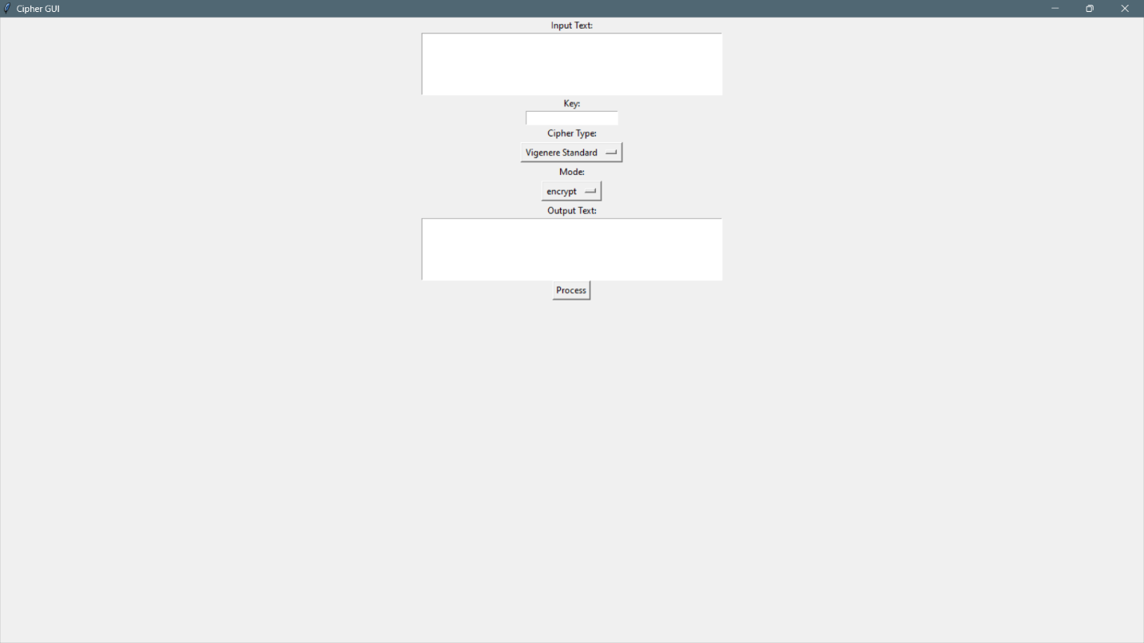

Contoh Plaintext dan Ciphertext

